Whiteout

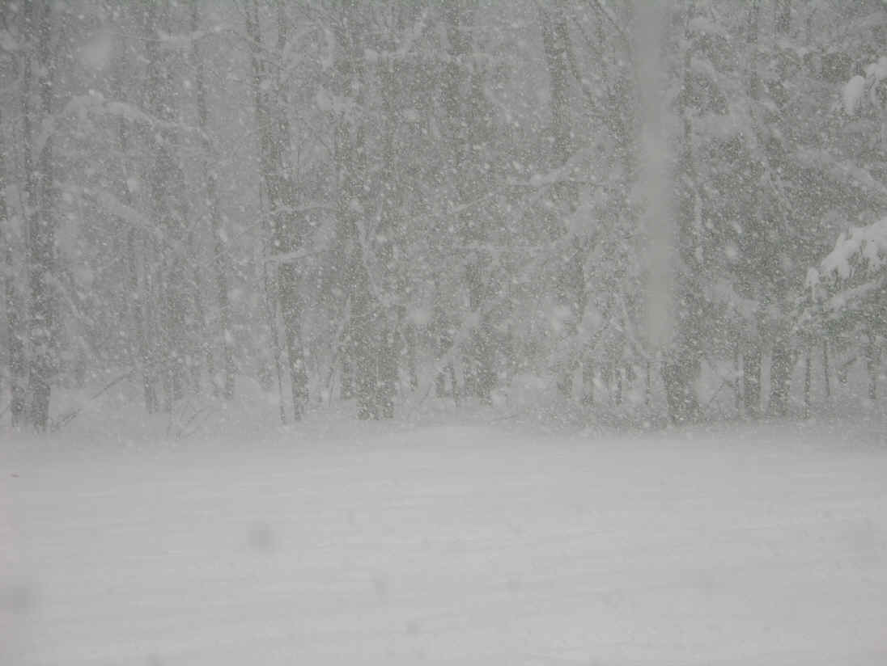

Snow is falling so fast you cannot see anything

