Permafrost

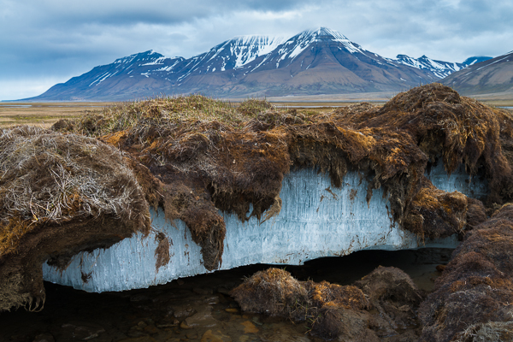

Top layer of the soil is soggy, but the soil underneath is frozen

