Eurasia

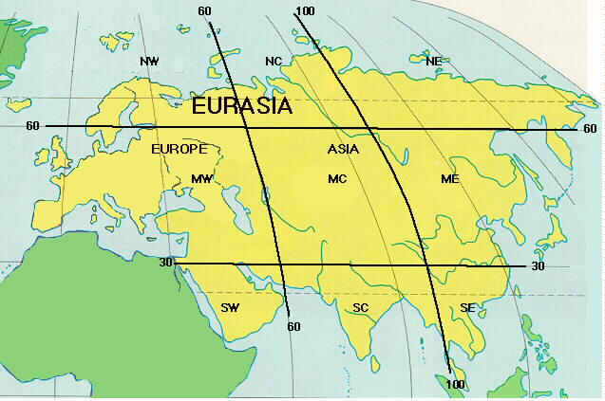

Both the continents of Europe and Asia put together is called Eurasia

