Adaptations

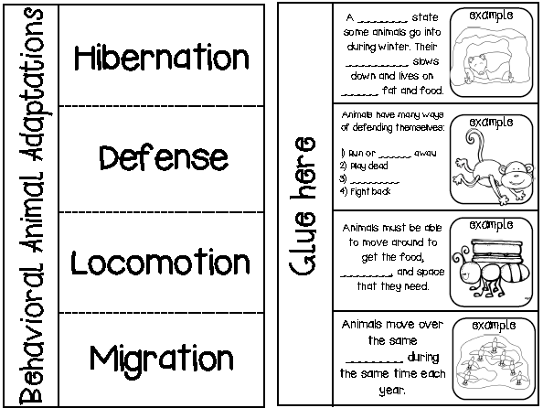

A feature or behavior that helps an animal survives.

